LAB PROGRAMS
7.Write a Pandas program to create a Pivot table and find the maximum and minimum sale value of the items.
Aim
To create a Pivot Table using Pandas and determine the maximum and minimum sale values for each item.
PROGRAM
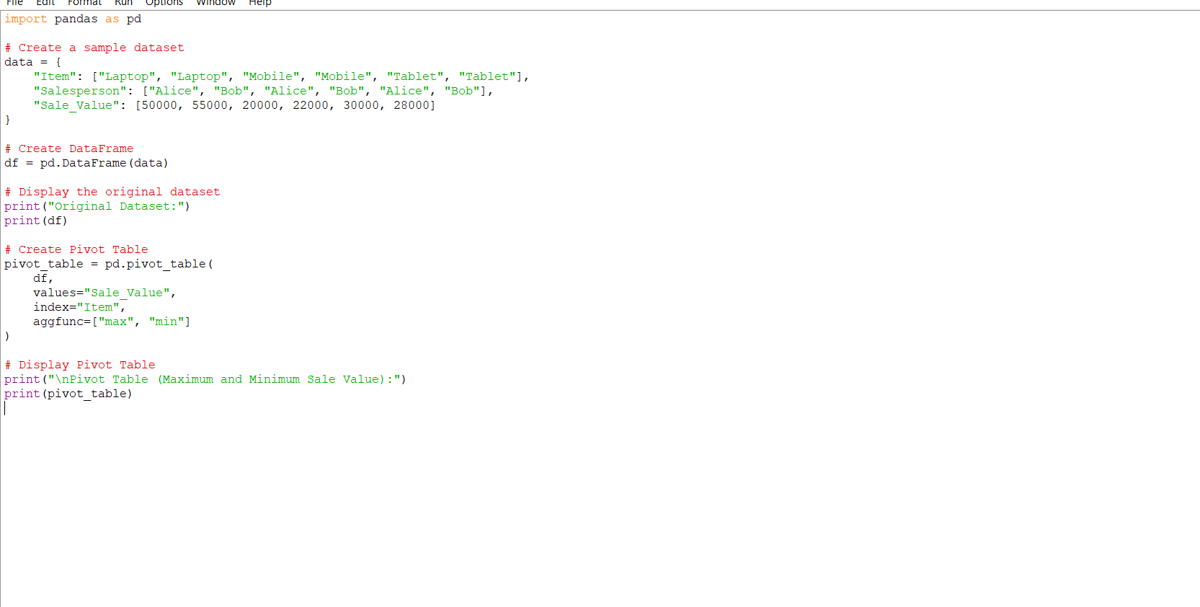
OUTPUT:
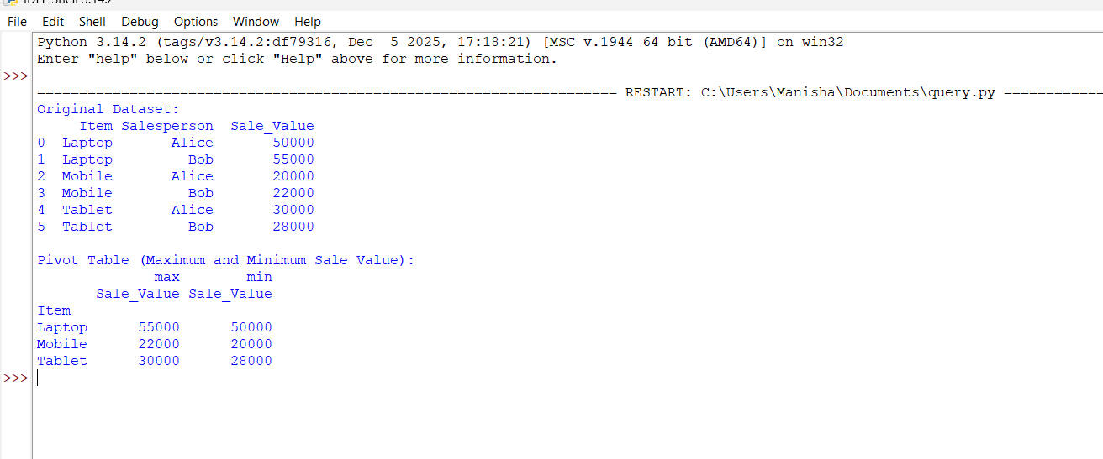
Result
Thus, the Pivot Table was successfully created using Pandas, and the maximum and minimum sale values for each item were determined successfully.
8.Write a Pandas program to create a Pivot table and find the item wise unit sold.
Aim
To create a Pivot Table using Pandas and find the item-wise units sold.
PROGRAM

OUTPUT:
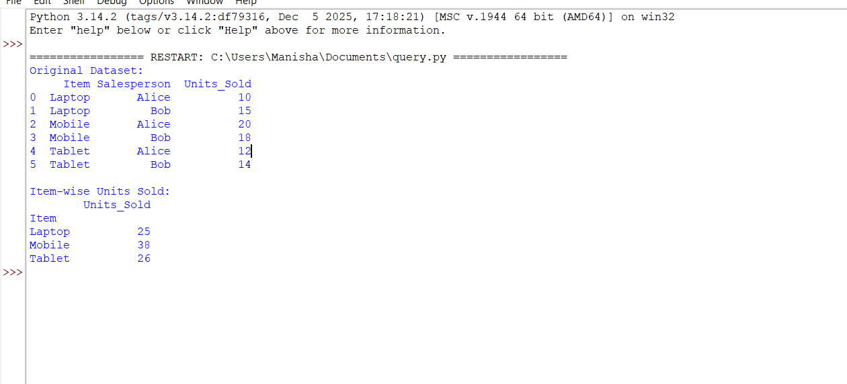
Result
Thus, the Pivot Table was successfully created using Pandas, and the item-wise units sold were calculated successfully.

